**Instructions for use**

**Arm sphyngomanometer**

**Features**

* One touch easy measurement
* Xx memories
* Easy to read display

**Introduction**

Blood pressure measurements taken with this device are equivalent to those obtained by a trained using armband/stethoscope auscultation method, within the limits prescribed by the EN 1060 standard.

This device is designed for use in adult only.

**Caution**

**Please read manual carefully berfore use. For specific information on your own blood presseure, please contact to your doctor. Keep this manual in a safe place for the future reference.**

**Schematic**

**Measuring technology**

This tensometer uses the oscillometric method and korotkoff sounds method. Firsr off all the unit establish a baseline pressure equivalent to the atmospheric pressure( offset differential pressure), the following step is to inflate de armband.

As it inflates, tensometer begins to measure your pressure oscillations and korotkoff sounds, such a way amplitude and gradient of oscillations have been determined and the korotkoff sound have dissapeared, the unit calculate your pressure by both methods, and will display systolic, diastolic and pulse rate value.

**Preliminary remarks**

This sphyngomanometer complies with European regulations and is CE mark pending. The quality of the unit has been verified and conforms with provisions of european Concil directive 93/42/EEC and its modificaction 2007/47/CE, as well as EMC directive 89/336/EEC:

* UNE-EN 1060-1:1996+A2:2010
* UNE-EN 1060-3:1997+A2:2010
* UNE-EN 1060-4:2005

To ensure accurate measurements, the calibration of the unit should be checked every two years.

**Explantion on arterial blood pressure**

*What is arterial blood pressure?*

Arterial blood pressure is the pressure exerted on the artery as blood flow through it. The pressure measured when heart contracts and pump out blood is the systolic pressure (highest). The pressure mearured when heart dilates and flows back is called diastòlic (lowest) blood pressure.

Why measure your blood pressure?

Amongst the various Health problems afflicting modern society, problems linked to high blood pressure are by far the most common. The dangerous relationship between high pressure and heart disesase, characterised by high morbidity, has made necessery to monitor blood pressure in order to identify those at risk.

**Blood pressure Standard**

The world Health Organization (WHO) has established a blood pressure Standard, indentifying risk areas for hypotension (low blood pressure) and hypertension (high blood pressure. This Standard, however, is intented as a general guideline beacause individual blood pressure measurements vary according to populartion, age group, etc.

It is important to consult your doctor reguraly. Your doctor will be able to tell you normal pressure range as well as the point at which you should consider yourself at a risk.

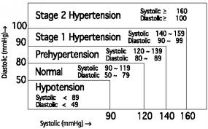

**Blood pressure fluctuation**

Do not worry if two or three measurements are high. Blood measuremts flucutates the month or even throghout the day. It is influecenced by the season and temperature.

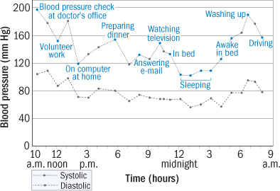

This graph shows blood pressure changes in a 73-year-old woman over a 24-hour period. They were recorded using an ambulatory blood pressure monitor, a technology clinicians use to investigate possible cardiovascular problems. A spike in the woman’s blood pressure at her clinician’s office in the morning suggests she may have white-coat hypertension. Her average blood pressure was 141/77. (from http://www.health.harvard.edu/newsletters/Harvard_Womens_Health_Watch/2009/August/Experts-call-for-home-blood-pressure-monitoring

**Symbols**

**Power supply**

**How to take your blood pressure** 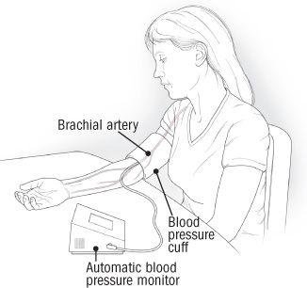

Upper-arm monitors measure blood pressure in the brachial artery, which passes along the inside of the elbow and continues up the arm. This is the type of monitor you should use; a wrist or finger monitor is not as reliable.

Sit quietly for five minutes, with your feet on the floor and your back well supported. Your arm should be resting on a flat surface, with the upper arm at the level of the heart. Position the cuff so that its midportion lies over the artery. (Some cuffs are imprinted with an arrow to help with positioning.) Most people find it easier to measure blood pressure in the nondominant arm. Avoid caffeine, alcohol, smoking, and exercise for at least 30 minutes before taking your blood pressure. (from http://www.health.harvard.edu/newsletters/Harvard_Womens_Health_Watch/2009/August/Experts-call-for-home-blood-pressure-monitoring

**Taking a measurement**

**Recall values from memory**

**Helpful tips**

Here are few helpful tips to help you obtain more accurate readings:

* Do not measure your blood pressure immedaitley after eating a large meal. To obtain accurate readings, wait at least one hour before measuring your blood pressure.
* Do not smoke or consume alcohol measuring your blood pressure.
* Do not measure your blood pressure when you are physycally tired.
* It is important to relax during measuring. Try to rest at least 15 minutes before measure your blood pressure.
* Do not measure your blood pressure if you are tense or under stress.
* Measure your blood pressure at normal body temperature. If you are feeling hot or cold, wait a while before taking a measurement.
* If the monitor is stored at low temperature (near freezing), put in warm place for at least one hour before use.
* Leave at least 5 minutes between each measurement.

**Troubleshooting**

**if**

**Warnings**

**Specifications**